

**OOP LAB**

**Lab Report No. 01**

**Submitted By: Jamshid Bacha**

**Regesteration No. 16PWCSE1404**

**Submitted To: Engr. Sumayya Salahuddin**

**Section: B**

**Batch: 18**

**Department: CSE**

**Date: 4-10-2017**

**University of Engineering and Technology Peshawar**

**Task 01:**

**CODE:**

#include<iostream>

#include<stdlib.h>

void swp(int &a,int &b);

using namespace std;

int main()

{

int i,j,size;

cout<<"Enter Number of Element that You Want to Reverse: ";

cin>>size;

int arr[size];

for(i=0;i<size;i++)

{

cin>>arr[i];

}

cout<<endl<<"The Element that you Entered: "<<endl<<endl;

for(i=0;i<size;i++)

{

cout<<arr[i]<<" ";

}

cout<<endl;

for(i=0;i<size;i++)

{

for(j=0;j<size-1;j++)

{

if(arr[j]<arr[j+1])

swp(arr[j],arr[j+1]);

}

}

cout<<endl<<"The Revers Array is: "<<endl<<endl;

for(i=0;i<size;i++)

{

cout<<" "<<arr[i];

}

}

void swp(int &a,int &b)

{

int temp;

temp=a;

a=b;

b=temp;

}

**RUN:**

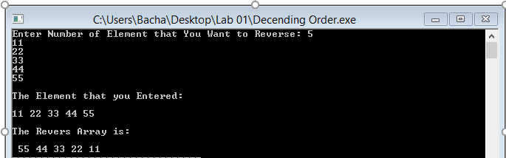

**Task 2 : 1.2.3 Activity**

**CODE:**

#include<iostream>

using namespace std;

int main()

{

int n,i,j;

cout<<"Enter the Number of Rows OR Columns: ";

cin>>n;

int arr[n][n];

int arrt[n][n];

for(i=0;i<n;i++)

{

for(j=0;j<n;j++)

{

cin>>arr[i][j];

}

}

cout<<endl;

cout<<"The Orignale Matrix: "<<endl;

for(i=0;i<n;i++)

{

for(j=0;j<n;j++)

{

cout<<arr[i][j]<<" ";

}

cout<<endl;

}

cout<<endl;

for(i=0;i<n;i++)

{

for(j=0;j<n;j++)

{

arrt[i][j]=arr[j][i];

}

}

cout<<"The Traspose of Matrix: "<<endl;

for(i=0;i<n;i++)

{

for(j=0;j<n;j++)

{

cout<<arrt[i][j]<<" ";

}

cout<<endl;

}

return 0;

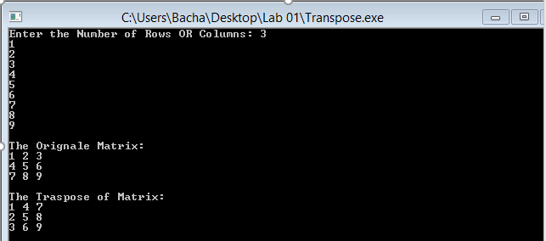}

**RUN:**

**TASK 03: 1.2.4 Activity**

**CODE:**

#include<iostream>

int gcd(int x,int y);

using namespace std;

int main()

{

int x,y;

cout<<"Enter X: ";

cin>>x;

cout<<"Enter Y: ";

cin>>y;

cout<<endl<<"GCD of "<<x<<" and "<<y<<" Is: "<<gcd(x,y);

return 0;

}

int gcd(int x,int y)

{

if(y==0)

return x;

else

return gcd(y,x%y);

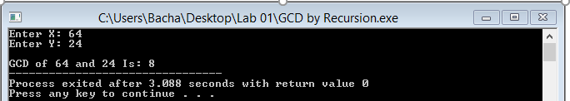}

**Task 04** **1.2.7 Activity**

**CODE:**

#include<iostream>

using namespace std;

int main()

{

int binum,temp,i=1,decimal=0;

cout<<"Enter Binary Number: ";

cin>>binum;

while(binum!=0)

{

temp=binum%10;

decimal=decimal+temp*i;

binum=binum/10;

i=i*2;

}

cout<<endl<<"The Decimal of Binary Number Is: "<<decimal<<endl;

return 0;

}

**RUN:**

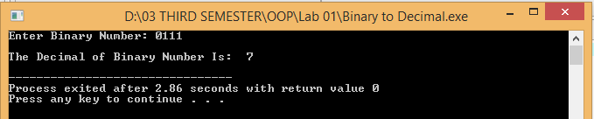

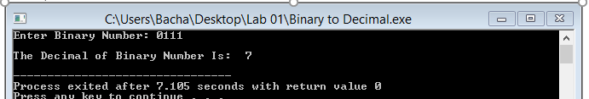

**TASK 05 1.2.9 Activity**

**CODE:**

#include<iostream>

#include<fstream>

using namespace std;

int main()

{

int arr[10];

ofstream file("bacha.txt");

for(int i=0;i<10;i++)

{

cin>>arr[i];

}

if(!file.is_open())

{

cout<<"Not Open "<<endl;

}

else

{

for(int i=0;i<10;i++)

{

file<<arr[i]<<endl;

}

}

cout<<endl<<endl;

ifstream fileread;

fileread.open("bacha.txt");

if(!fileread.is_open())

{

cout<<"Error: ";

}

else

{

string line;

while(fileread.good())

{

getline(fileread,line);

cout<<line<<" ";

}

}

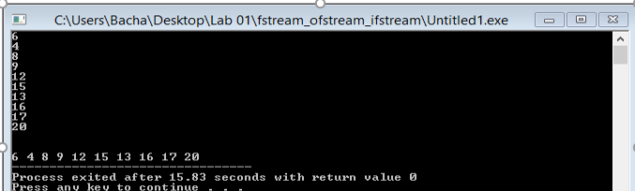 return 0;

}

**RUN:**

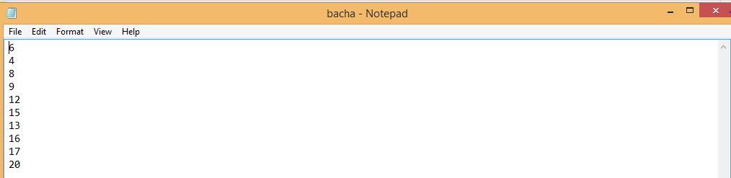

**TASK 06: 1.2.5 Activity**

**CODE:**

#include<iostream>

#include<stdlib.h>

using namespace std;

int main()

{

int size,i,j;

cout<<"Enter the Size of Array: ";

cin>>size;

float *arr = new float[size];

for(i=0;i<size;i++)

{

cin>>*(arr+i);

}

for(i=1;i<size;i++)

{

if(arr[0]<*(arr+i))

{

arr[0]=*(arr+i);

}

}

cout<<"The Largest from the Numbers Is: "<<arr[0]<<" ";

return 0;

}

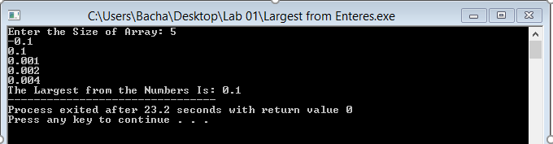

**TASK 07: 1.2.6 Activity**

**CODE:**

#include<iostream>

using namespace std;

int main()

{

int arr[4],i,encr[4],decr[4];

for(i=0;i<4;i++)

{

cin>>arr[i];

}

cout<<endl;

cout<<"Originol Number: "<<endl;

for(i=0;i<4;i++)

{

cout<<arr[i];

}

cout<<endl;

for(i=0;i<4;i++)

{

encr[i]=(arr[i]+7)%10;

}

cout<<endl;

cout<<"Encrepted: "<<endl;

for(i=0;i<4;i++)

{

cout<<encr[i];

}

cout<<endl<<endl;

cout<<"After swaping: "<<endl;

cout<<encr[2]<<encr[3]<<encr[0]<<encr[1];

for(i=0;i<4;i++)

{

decr[i]=(encr[i]+10)-7;

}

cout<<endl;

cout<<endl<<"Decripted: "<<endl;

for(i=0;i<4;i++)

{

cout<<decr[i];

}

cout<<endl;

return 0;

}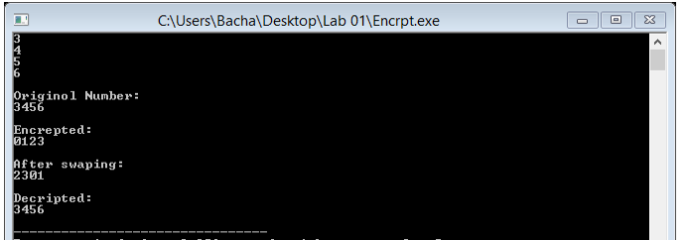

**TASK 08: 1.2.8 Activity**

**CODE:**

#include<iostream>

#include <stdlib.h>

#include <time.h>

using namespace std;

int main()

{

int array[100],i;

int repet[100]={};

srand(time(NULL));

for(i=0;i<100;i++)

{

array[i]=rand()%100;

}

for(i=0;i<100;i++)

{

repet[array[i]]++;

if(repet[array[i]]==2)

{

cout<<"Repeated Element: "<<array[i];

break;

}

}

return 0;

}

**RUN 1:**

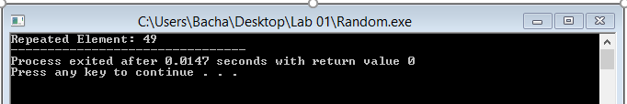

**RUN 2:**

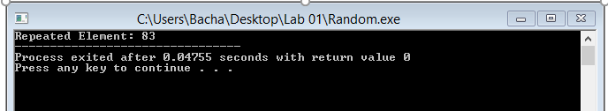

**Task 09:** **1.2.2 Activity**

**CODE:**

#include<iostream>

#include<cmath>

using namespace std;

int main()

{

int n;

double mean,ans=0,res,answer;

double sum=0;

cin>>n;

int arr[n],i,j;

for(i=0;i<n;i++)

{

cin>>arr[i];

}

for(i=0;i<n;i++)

{

sum+=arr[i];

}

cout<<"Totle: "<<sum<<endl;

mean=sum/n;

cout<<"Mean: "<<mean<<endl;

for(i=0;i<n;i++)

{

ans+=pow((arr[i]-mean),2);

}

res=ans/(n-1);

cout<<endl<<"Before squere root: "<<res<<endl;

answer=pow(res,0.5);

cout<<"Answer: (+-) ";

cout<<answer;

return 0;

}

